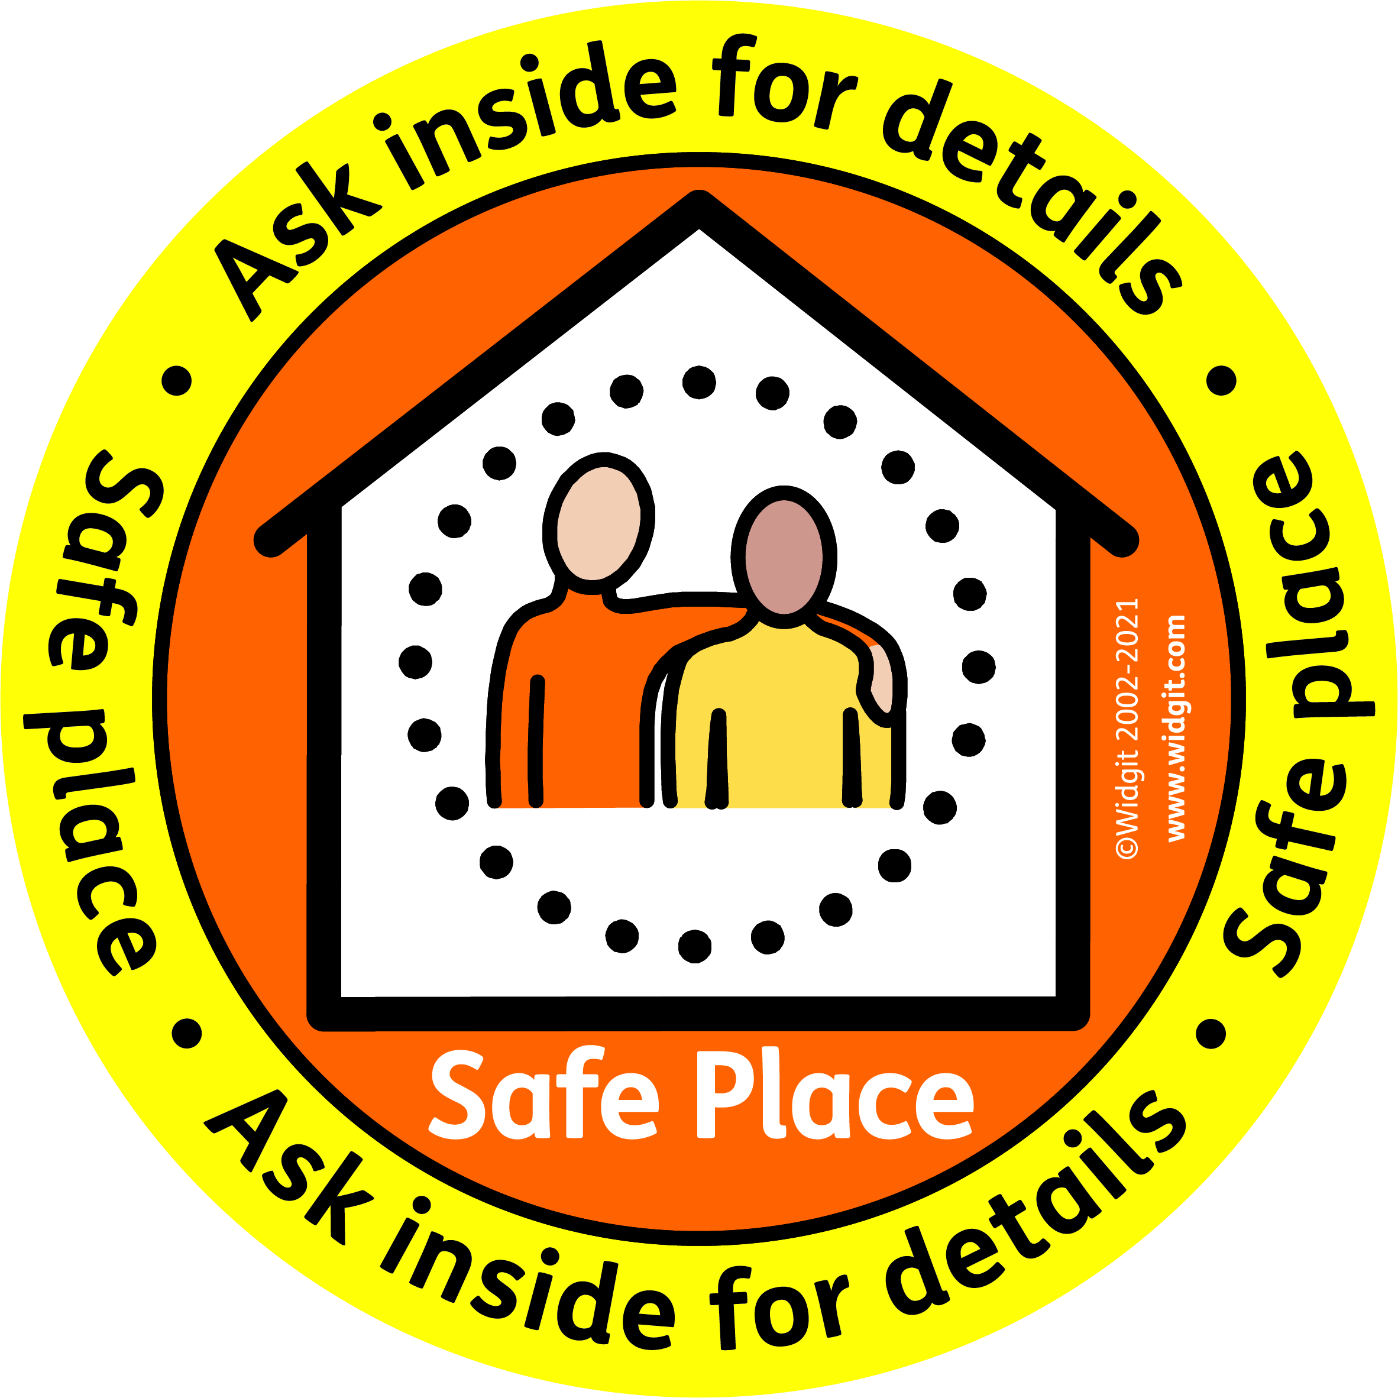In House Awareness Record

Name | Date Trained (read information in Information Book and watched video)

