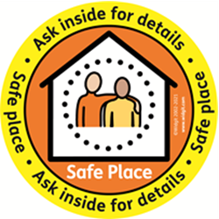
Rochdale Safe Place Scheme
Incident Form
Please complete this form when somebody comes into your premises looking for a Safe Place.
Do not record any personal or identifiable information, and only fill this form in after the adult has left the Safe Place location.
Organisation Name

What time and date did the person come into the location?

What was the problem? (e.g. Lost, hate crime, medical emergency, confused)

How did you help?

Additional Information/Comments (Optional)
Please send this completed form to Melanie Chapman, Future Directions CIC, Marle House, Broadway Business Park, Broadgate, Chadderton, OL9 9XA.
You can email Melanie at melanie.chapman@futuredirectionscic.co.uk or phone her on 07421 387 765.
Thank you for your assistance and support.

