
Gender Pay Gap Reporting
Future Directions CIC is committed to addressing workplace barriers to equality and providing all employees with equal opportunities. Our strategic aim is to fully engage and value all our employees. We are a diverse workforce and we have worked collabroatively and succesfully since the company became independent in 2015.
This involves carrying out six calculations that show the difference between the average earnings of men and women in our organisation. We are required to publish the results on our own website and a government website within one calendar year of April 5th.

We can use these results to assess:
- the levels of gender equality in our workplace
- the balance of male and female employees at different levels
- how effectively talent is being maximised and rewarded.

The challenge in our organisation is to eliminate any gender pay gap. The Company has always worked hard to ensure that there is a fair system of pay across the Company and this effort is evident in the results of our report.

Gender Pay Reporting requires us to make calculations based on employee gender. We establish this by using our existing HR and payroll records.

In April 2025 the company employed 863 staff of these, 334 were male and 529 were female.
Hourly Rates of Pay
The organisation found that there was a – 0.7% Gender pay gap on mean salaries between male and female employees, and a 0.87% pay gap on the median basic hourly rate. This means that there is a very slightly higher rate of pay for female employees across the organisation as a whole. The mean and median bonus pay gap is 0.51% and 0%. Bonus pay is virtually the same for both male and female employees.

The mean and median gender pay gap – based on an hourly rate of ordinary pay

Mean gender pay gap – 0.7% Median gender pay gap - 0.87 % Total Employees 863
Pay Bands
Below is the summary split of where male and females sit in terms of the quartile pay bands. We listed the salary of every colleague in order and split the list into four equal parts to give us our quartiles 1, 2, 3 & 4.

796 895
 | Number of Male | % of Males | Number of Females | % of Females | Total staff
Quartile 1 | 71 | 33% | 145 | 67% | 216
Quartile 2 | 90 | 42% | 126 | 58% | 216
Quartile 3 | 106 | 49% | 110 | 51% | 216
Quartile 4 | 67 | 31% | 148 | 69% | 215

Total Employees 863

Note: Any difference in total employee numbers shown in the data is as a result of the different methodologies that employers are required to use by the regulations. This will exclude some staff on reduced pay or unpaid leave.

SUMMARY
The figures shown in our gender pay-gap report show that the company has a pay structure and other processes which ensure that discrimination based on gender is not currently an issue within Future Directions CIC. We are confident that men and women are paid equally for doing equivalent jobs across our business.

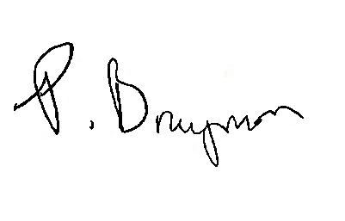
Paula Braynion
Managing Director

